* Creating and deleting directories in Ubuntu

Go to the working directory path you want to create the directory in. Use the mkdir command in the format “mkdir **newName1 newName2 …**” to create the directories.

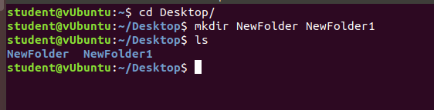

Go to the working directory path of the target directory. Use the ‘rm -rf’ command in the format “rm -rf **dirName1 dirName2 …**” to remove target directories.

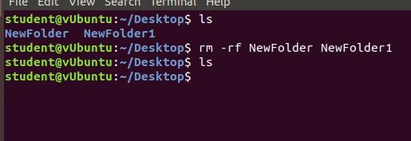

* Creating and deleting directories in WIndows

Go to the working directory path you want to create the directory in. Use the mkdir command in the format “mkdir **newName1 newName2 …**” to create the directories.

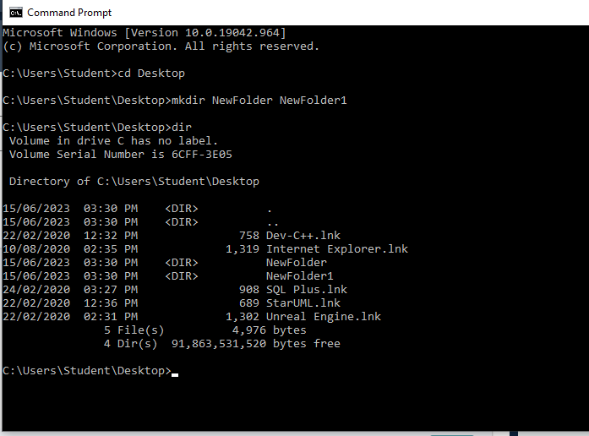

Go to the working directory path of the target directory. Use the ‘rd’ command in the format “rd **dirName1 dirName2 …**” to remove target directories.

